The West Virginia Reading Association
Issues
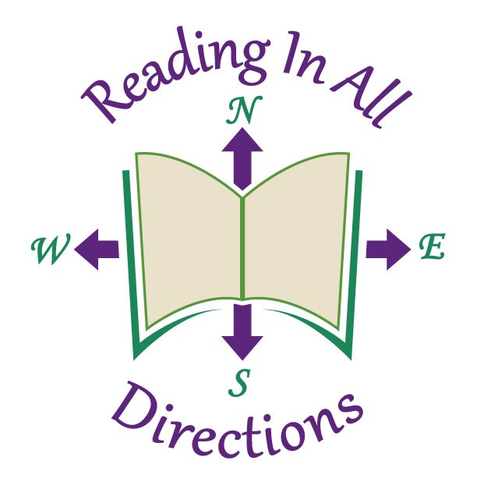
A Call for Conference Exhibitors for

WVRA 62nd Conference
November 16 and 17, 2017

At The Greenbrier

White Sulphur Springs, West Virginia 24986

Exhibitor Registration Deadline-October 23, 2017

Reasons to Purchase Exhibit Space

The West Virginia Reading Association is the largest professional organization devoted to reading instruction in West Virginia.

During the annual WVRA Conference, over 600 educators from all over West Virginia and several surrounding states will go through the exhibit hall.

This conference provides an opportunity for vendors to showcase some of their new and exciting materials.

Conference participants say they learn valuable information in the exhibit hall to improve instruction in their classroom because they are provided the opportunity to see and learn about the latest instructional materials, technology and services from the vendors. As a result some conference attendees will purchase items to use in their classrooms.

Higher Education vendors have an opportunity to recruit educators for their graduate degree programs.

Conference Overview

This year’s 62nd Conference Theme is Reading in all Directions. What better investment in reading can an educator make than to have the latest instructional materials, technology and best-selling books designed to target the reading, writing, speaking and listening needs of students in all grades, all subjects and all ability levels.

The West Virginia Reading Association cordially invites you to plan, prepare, and reserve exhibit space. Vendors have always been an integral part of the success of the conference. We greatly appreciate all that you do for educators throughout the state. The support you give WVRA is especially notable.

WVRA 2017 Annual Conference
Exhibit Registration Form
November 16 and 17, 2017
The Greenbrier, 300 W. Main Street

White Sulphur Springs, WV

WVRA Tax Exempt Number: 556028358

Company Name and Address:____________________________________________________
____________________________________________________________________________

Representative’s Name/Address__________________________________________________

____________________________________________________________________________

Phone ______________________ Fax _____________________________________

E-Mail ________________________________________________________________

Number of tables at $250.00 per table ___________ Amount enclosed: $______
Electricity: Yes ________ No______

Phone/Internet: Arranged through The Greenbrier Sales Office by the vendor.
Special Needs: ___________________________________________________
________________________________________________________________
________________________________________________________________
________________________________________________________________

Door Prizes: Yes_____________ No ____________________

Names for nametags:
______________________ _______________________

______________________ _______________________

Please Note:
To guarantee exhibiting space, all fees must be paid to the West Virginia Reading Association on or before October 23, 2017. Exhibiting space will not be guaranteed until table fees are paid in full.

Return this form and check made payable to: WVRA to:

Brenda Chadwell
Frances Horton FAX: 304-736-3297
6019 Pullen Ct. E-mail: franread@aol.com
Barboursville, WV 25504 Phone: 304-736-5839

Table fee: $250.00 per table for Thursday and Friday.

GENERAL VENDOR INFORMATION

Conference Date: November 16-17, 2017

Place: The Greenbrier – Exhibit Hall

Tables: 8' x 30" (Electricity Available)

Technical Needs: Phone/internet arranged by vendor through
The Greenbrier sales office
(304-536-7837)

*Exhibit Set Up: 2:00 p.m. - 5:00 p.m., Wednesday, Nov. 15
*Exhibit Hall Schedule 8:00 a.m. - 5:00 p.m., Thursday, Nov. 16
7:00 a.m. - 2:30 p.m., Friday, Nov. 17
*Exhibits Dismantled: By 5:00 p.m. on Friday Nov. 17
* Times listed are tentative – check nearer to conference date

/Check at the Service Entrance for directions to Exhibit Hall loading and unloading area.

/Exhibitors are asked to indicate on the table registration form any special needs such as wall space (unavailable unless the floor plan is changed) and/or affiliate company table space.

/Tables will be labeled with company names.

/Door prizes are to be given out by exhibitors at their table or given to Hospitality Co-Chairs: Janet Foss or Viki Caldwell for distribution at the closing session.

/Exhibit fees cannot be returned after October 21, 2017

MERCHANDISE FORWARDING:

All packages should be mailed to:
Guest Name & Company, WVRA Exhibits
Attention: Bibbs Tolley, Porter
300 West Main Street
White Sulphur Springs, WV 24986

